UCL ALUMNI
LONDON GROUP

London Group events, March – June 2021

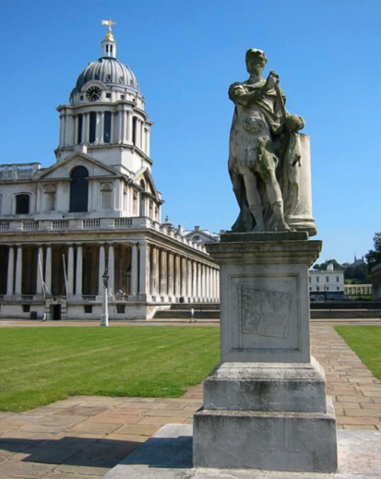
(All these events are likely to be virtual, using Zoom)

Dear Fellow Alumni,

With Covid fighting back and confusing our leaders, and our best hope being vaccination, though this may be some way off, we are fighting back with a programme of 8 Zoom events taking us up
until June.

In addition to the three Zoom events scheduled for January and February we are getting close to the number of events we typically ran in the past over 6 months in the real world.

The programme has great diversity of locations and topics, some only possible in the virtual world. So please fill up your diary whilst supporting your Alumni Group, and settle back in the safety, comfort and warmth of your own home whilst watching live events where you can ask questions at the end.

With all good wishes,

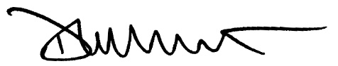
Dennis Wilmot (Psychology 1983)

Contact: John McKenzie, 51 Clifford Road, Barnet, Herts EN5 5PD. (j.mckenzie@ucl.ac.uk)

1. Friday 5 March 2021 at 4.00 pm.
Prime-mover: Jane Bowden-Dan
(History of Science Medicine & Technology 2000)

Royal Greenwich: Meridians, Murder & Maritime History

a tour led by Tim Barron, from UKToursOnline

On this virtual tour we will disembark
7 miles east of central London, on the South bank of the river Thames, as did George 1st, at the Royal Naval College.

We will take in the breathtaking, Sir Christopher Wren designed, Painted Hall (movie buffs please take note). The Hall’s foundations are from the Palace of Placentia where Henry VIII was born, where he married Catherine of Aragon and celebrated the birth of their first child Mary.

The Royal credentials continue with Henry V’s brother enclosing the hunting park that was the venue for the 2012 Olympic equestrian events. The Queen’s House, Inigo Jones’s Palladian masterpiece, displays the Armada Portrait of Queen Elizabeth 1st and a multitude of naval treasures.

We will visit the Cutty Sark, the last and the fastest tea clipper, before we enter the Maritime Museum, with the largest collection of ‘things nautical’ in the world.

At the top of the hill is the Royal Observatory “The place where time begins!”: the location of the Meridians, the Harrison clocks, the gorgeous Octagon room (by Sir Christopher Wren of course) topped by the time ball. Joseph Conrad chose this stunning view point as the site of the key scene in his terrorist novel, The Secret Agent.

£14. Maximum number 30.

2. Wednesday 10 March 2021 at 5.30 pm.
Prime-mover: Janet Kitchen (French 1964)

Victorian Deptford: a walk led by Sean Patterson,
RADA trained actor and accredited London guide.

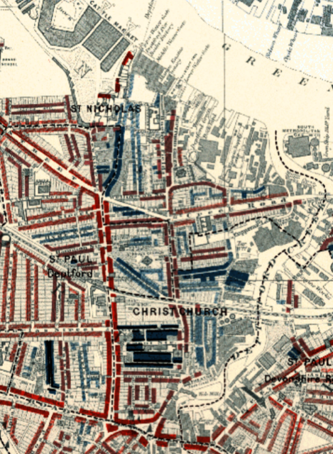
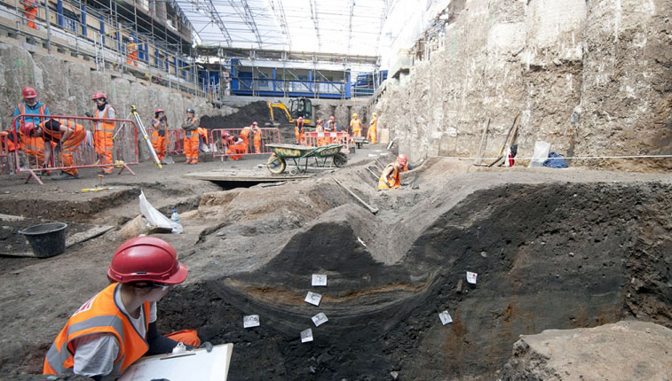
Sean's in-depth knowledge of Victorian Deptford is drawn from the famous poverty maps of London, compiled by ship-owner, philanthropist and social pioneer, Charles Booth, author of the "Inquiry into Life and Labour in London" and based on the painstaking surveys he undertook between 1889 and 1902.

He will offer fascinating insights into the varied lifestyles and living conditions of the former residents of one of London's toughest neighbourhoods towards the end of the 19th century, as well as sharing his knowledge about the general history of the area since Tudor times and looking forward to its future as one of London's gentrification hotspots.
£14. Maximum number 30.

3. Wednesday 7 April 2021 at 2.30 pm.
Prime-mover: Belinda Tincknell (Psychology 1973)

Tour: ‘Crossrail archaeology’,
led by award-winning Blue Badge Guide Leo Heaton

This virtual tour will escort you down to the tunnels and brand new rail stations of Europe’s largest ever infrastructure project, Crossrail, to have a closer look at the finds unearthed during its construction.

From everyday items, like Victorian chamber pots and Roman coins, to rare treasures such as medieval bowling balls and also a piece of 55 MILLION year old amber – come and explore the sites and some of the objects that this remarkable project uncovered one by one.

Is it true that bodies were discovered still carrying 14th century plague pathogens? What gruesome discovery had to make way for the new Liverpool Street station ticketing hall? And what on earth were 13,000 jam jars doing buried underneath Tottenham Court Road?!

Join Leo to spend a fascinating hour putting together a few more of the pieces that make up London’s archaeological jigsaw puzzle.

£14. Maximum number 30.

4. Tuesday 20 April 2021 at 4.00 pm.
Prime-mover: Maggie Smith (Geography 1970)

Cheddar Man and the genetic prehistory
of Britain - the story so far . . .
A talk by Dr Tom Booth (Crick Institute)

Tom Booth is Senior Research Scientist in the Ancient Genomics laboratory of the Francis Crick Institute led by Dr Pontus Skoglund.
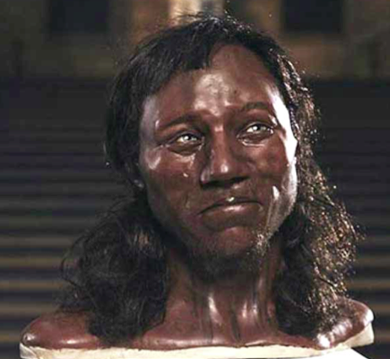

The last 10 years has seen a revolution in the way that we study DNA extracted from ancient human remains.

These revitalised techniques are providing rich insight into the demographic prehistory of Europe.

This talk will discuss major stories emerging from the analysis of ancient human remains from Britain, including the 10,000 year old Cheddar Man, Britain's oldest mostly-complete fossil skeleton.

These results are beginning to paint a radical new picture of the people who inhabited Britain before written records began.

£11. Maximum number 30.

5. Wednesday 5 May 2021 at 9.00 am.
Prime-mover: Dennis Wilmot (Psychology 1983)

Talk: ‘Healthcare Improvement’,
by Professor Martin Marshall, FRCP

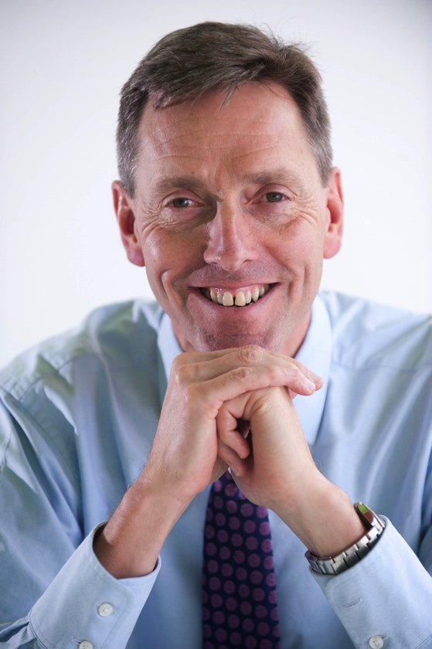
Martin Marshall is Chair of the Royal College of General Practitioners and a GP in Newham. He is also UCL Professor of Healthcare Improvement. Previously he has been Deputy Chief Medical Officer for England and Director General in the Department of Health.

He has advised governments in Singapore, Egypt, Canada and New Zealand, and his primary academic interest is in maximising the impact of research on practice. In 2005 he was awarded a CBE in the Queen’s Birthday Honours for Services to Health Care.

A co-founder and driving force of the Rethinking Medicine movement, Martin has a passionate commitment to the values of the NHS, patient care and ensuring the GP voice is central in a time of great change. In this context, he will try to answer the question
“What have we learned from the Covid crisis?”

£8. Maximum number 30.

6. Wednesday 19 May 2021 at 4.00 pm.
Prime-mover: John Gregory (Chemistry 1959)

Talk: ‘Charles Dickens’,
by UCL Professor John Mullan

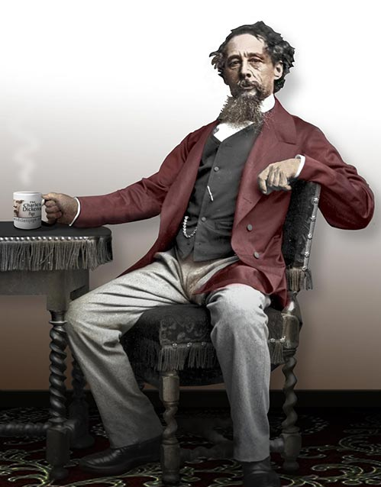
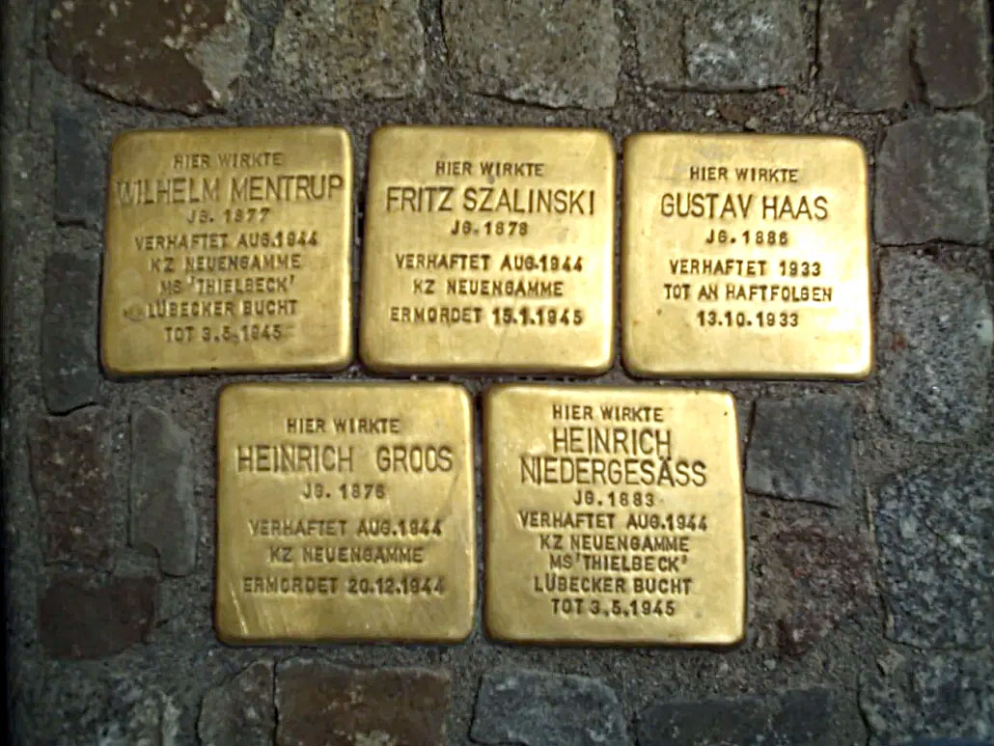
What is so good about Dickens’s novels? This talk will show how Dickens, frequently condescended to as an ‘entertainer’, was one of the most audacious and formally daring of all English novelists. He invented many of the tricks that later literary novelists would think their own. By offending against the decorum of literary English, he discovered new powers of expression. We will be looking at some highlights from novels written across his career.

John Mullan is Lord Northcliffe Professor of Modern English Literature at UCL. He is a regular TV and radio broadcaster and a literary journalist; he writes on contemporary fiction for the Guardian and was a judge for the 2009 Man Booker Prize. He has given previous talks to the Group, including a highly enjoyable presentation on Jane Austen in 2019. His most recent book is The Artful Dickens (2020), on which his new talk is based.

£8. Maximum number 30.

7. Tuesday 1 June 2021 at 3.00 pm.
Prime-mover: Kate Wickson (Classics 1972)

Talk: ‘The Counter Memorial Culture of Modern Germany’,
by Angela Findlay (artist, lecturer and writer)

How do you express national guilt and apology rather than pride
and patriotism? How to remember what you would rather forget?

In this country, very little is known about Germany’s unique
post-WW2 process of remembrance. With all traditional forms of memorial deemed irrelevant and inappropriate, German artists instead sought ways to honour the victims of one of history’s
darkest periods.

The ensuing and on-going ‘counter memorial’ movement places extraordinary art forms in key locations often at the heart of German cities, encouraging visitors to take personal responsibility for keeping the memories and lessons of the past alive. The results are brave, challenging, moving and inspiring.

With her Anglo-German roots and personal connection to the subject, Angela is ideally placed to give insights into this hugely interesting and topical subject.

£12. Maximum number 30.

8. Tuesday 22 June 2021 at 2.30 pm.
Prime-mover: Dennis Wilmot (Psychology 1983)

Talk: ‘Space Science and outreach’,
by UCL Professor Lucie Green (MSSL)

Lucie Green is a Royal Society University Research Fellow and a Professor of Physics in the UCL Department of Space & Climate Physics at the Mullard Space Science Laboratory.

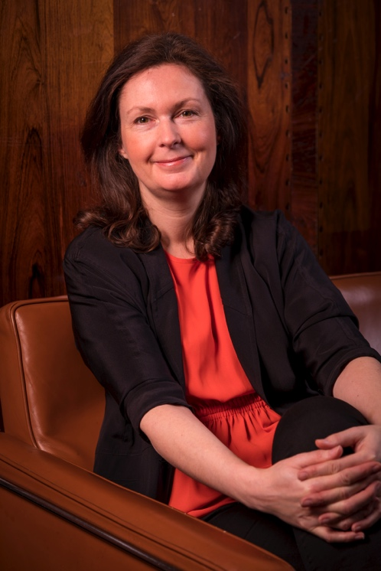
In her talk, she will discuss
her research that focuses on
our nearest star. The Sun is
110 times wider than Earth; it
is 15 million degrees at its core
and has an atmosphere so huge that Earth is actually within it. Within the Sun’s atmosphere,
the Solar System’s most energetic eruptions take place and the research aims to understand why.

Understanding the Sun’s magnetism is the key to understanding these eruptions and the role that so-called ‘magnetic flux ropes’ play.

Being a space scientist naturally lends itself to talking to schools and public audiences, so Lucie will also talk about her work in that area, in particular her role as Chair of Governors at the UCL Academy – a secondary school in London and the first to be solely sponsored by a university.

£8. Maximum number 30.

